- Introduction
The purpose of this project is to develop a simple three dimensional shooting game using OpenGL graphics. The game is a two player game where both players are human (no AI). The players play the game using controls (keys) on the same keyboard meaning this game is not a multiplayer game where network communication is required.
The players are represented by 3D shapes. The first player is a mainly a cylinder. Attached to the cylinder is a cube (coloured green) which represents the firing nozzle. In the middle of the cube there is a black circle representing the firing hole. The main body of the player (cylinder) is divided into two parts one coloured red (firing side with firing nozzle attached to it) and the other coloured blue (shield side). The second player is a torus and a sphere. The sphere is surrounded by the torus (like a planet with ring(s) around it). The firing nozzle is the same shape as player 1. It is attached to the torus on the firing side. The sphere and torus are both divided into two sides shield and firing. The shield side for both torus and sphere is coloured blue.
Each player can move in six directions (left, right, up, down, inwards of screen, outwards of screen) and rotate around any of the three axes (x, y, or z). The players can also rotate around all the possible combinations of axes (xy, xz, yz, xyz). The axis or set of axes that a player can rotate around is the player’s rotation mode. A player’s rotation mode can be changed using a glut menu. The user simply selects the axis (or set of axes – 7 choices/possibilities in total) and the player’s rotation mode changes. Rotating allows a player to fire from different angles. A player must rotate its firing side towards the other player to be able to hit the other player and, at the same time, risk being hit by the other player. The player firing system works by allowing a player to fire multiple bullets in any direction the player is pointing to. The firing is initiated by the use pressing a player’s firing button. The bullets are spherical in shape and they coloured blue for player 1 and green for player 2.
Lighting with OpenGL is a main feature of this game. When lighting is enabled (glEnable(GL_LIGHTING)), the normal colours of the players are disabled and lighting parameters are enabled. In this project, two lights can be enabled so there are three main possibilities with lighting, which are lighting off, one light on, and two lights on. For each of the two lights, a form with track/slider bars can used to set any combinations of the lighting parameters (specular, diffuse, and ambient). All the possible colours of visible light can be achieved by changing the lighting parameters. There is also a third form with slider bars that can be used to set the material properties.

- Players
The players are drawn using built-in glut functions (glutSolidSphere, glutSolidCube, glutSolidCylinder, and glutSolidTorus). For player 1, in order to have two sides shield and firing with two different colours, two half cylinders are used. A half cylinder is drawn by first drawing a cylinder using glutSolidCylinder then using a clipping plane to cut the cylinder in half. Two half cylinders with different colours are drawn. Then the two half cylinders and the firing nozzle are “glued” together using rotations (glRotatef) and transformations (glTranslatef). For player, the same strategy is used. Two half torus and two half spheres are drawing using built in functions and clipping planes. Then, the halves are glued together using rotations and transformations. The firing nozzle is also glued onto the torus firing side using rotations and transformations.
Here is a screenshot of the players:
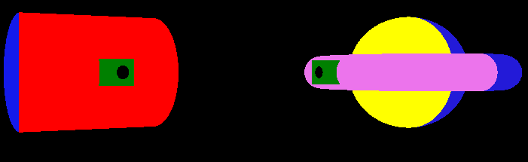
Player 1 & Player 2 in 3D

- Player Movement
Players move using keyboard keys. The key assignments are indicated below:
 | Move Left | Move Right | Move Up | Move Down | Move into the Window | Move out of Window
Player 2 | Left arrow key | Right arrow key | Up arrow key | Down arrow key | I or i | O or o
Player 1 | A or a | D or d | W or w | S or s | F or f | C or c

- Player Rotation
Players rotate by 3 degrees around a specified axis (x, y, or z) or a set of axes (xy, xz, yz, xyz). The rotation mode (which axis or axes player rotates around) is set using glut menus. Then the rotation around the chosen axis/axes is triggered using a rotation keyboard button.
 | Rotation
Player 2 | P or p
Player 1 | X or x

The following screenshots demonstrate player movement and rotation:
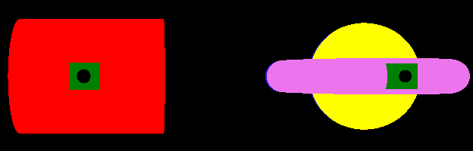
Player 1 & Player 2 initially located at centre facing camera
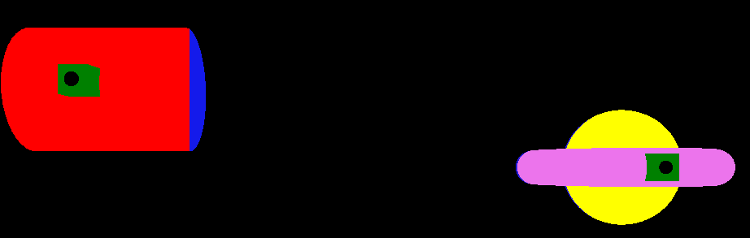
Player 1 moves upwards and to the left

NOTE: The background colour in the game is black, but the rest of the screenshots will be showing a white background to save ink.
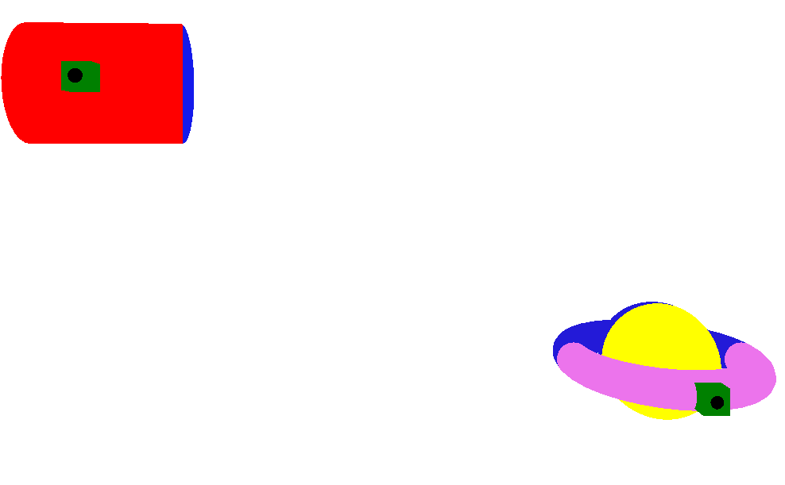
Player 2 moves down and to the right

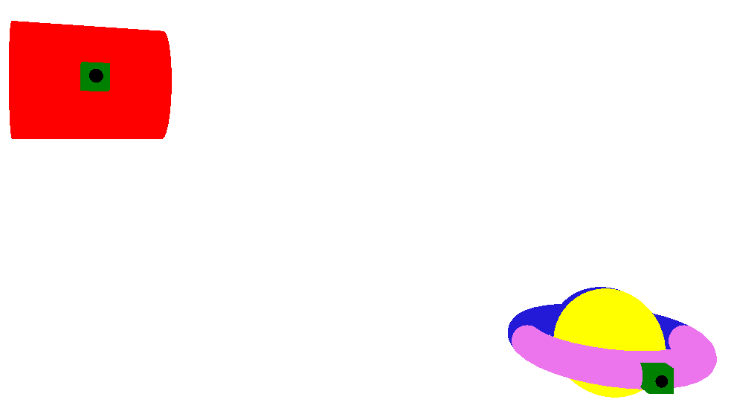
Player 1 rotating around the y axis
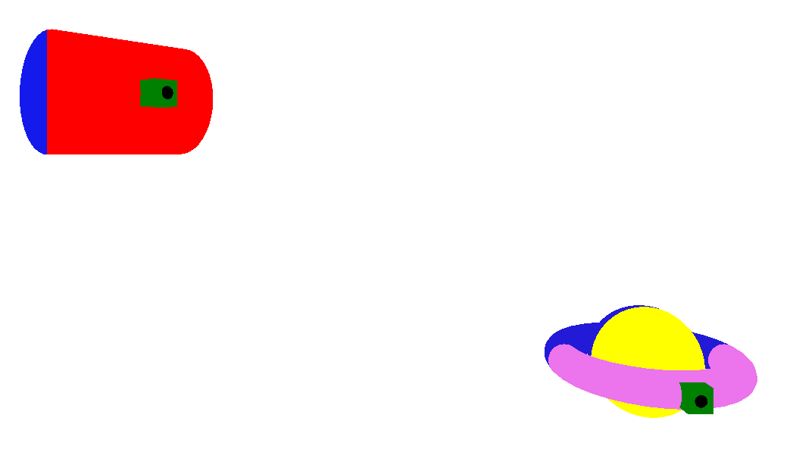

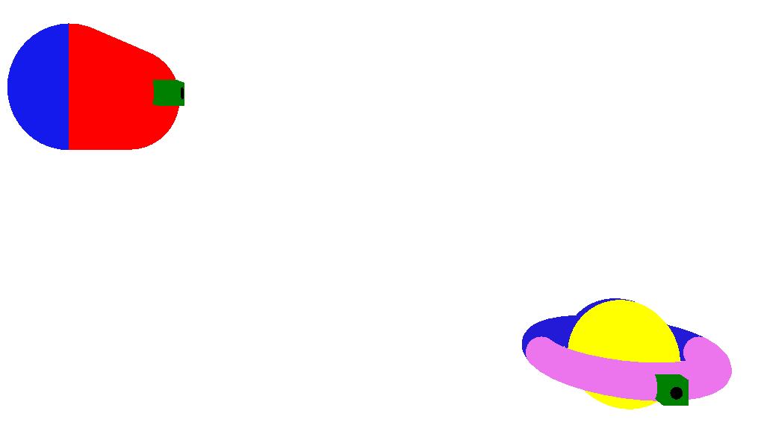
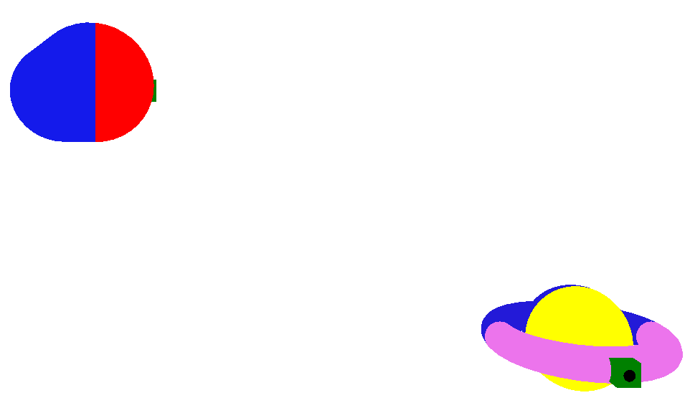

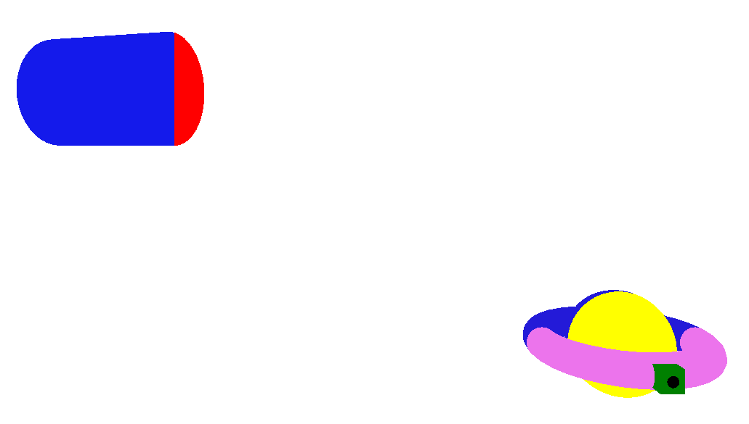
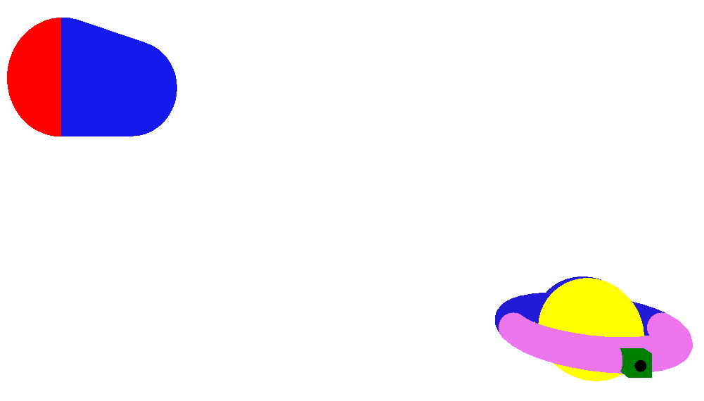

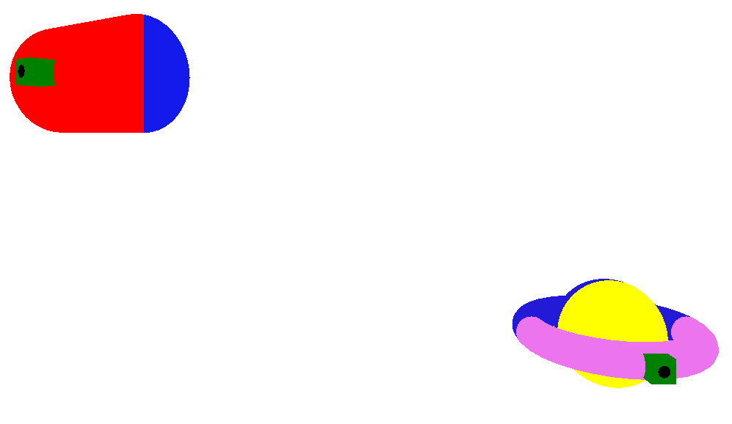
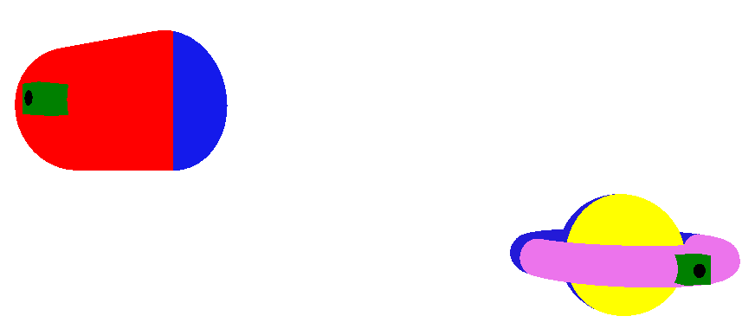
Player 2 rotating around the y axis

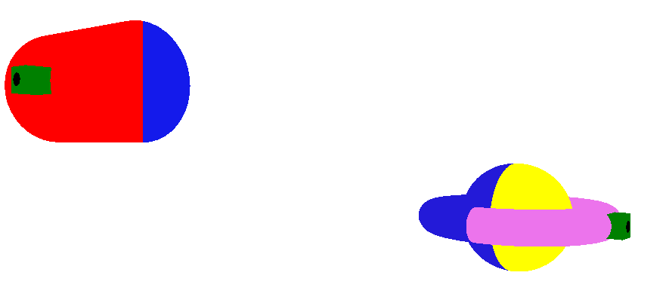
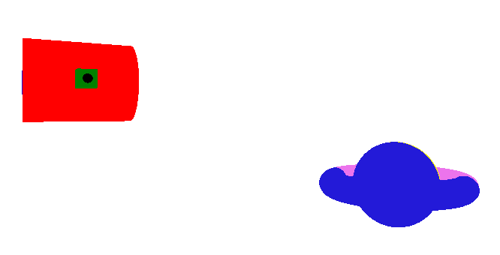
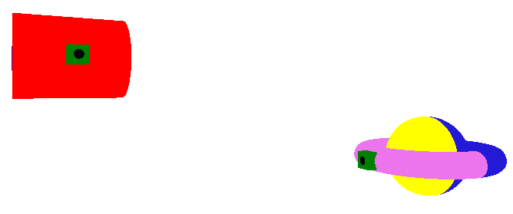
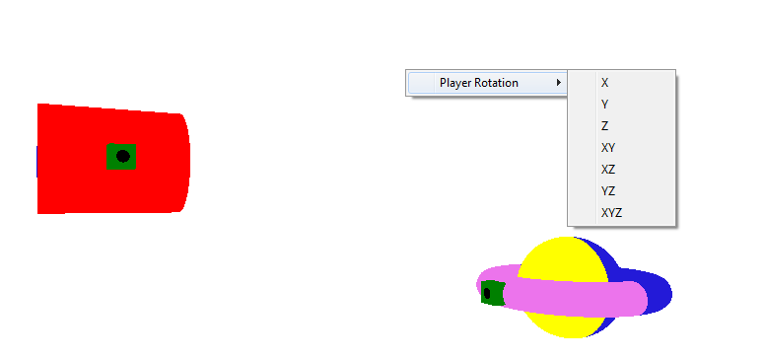
Player rotation mode can be changed using glut menu

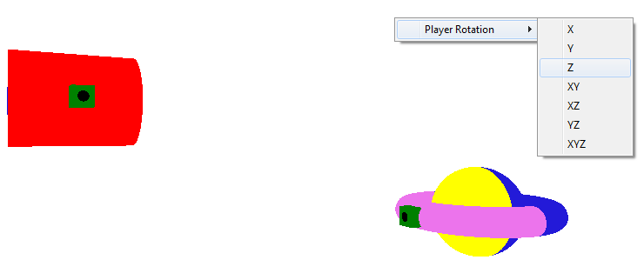
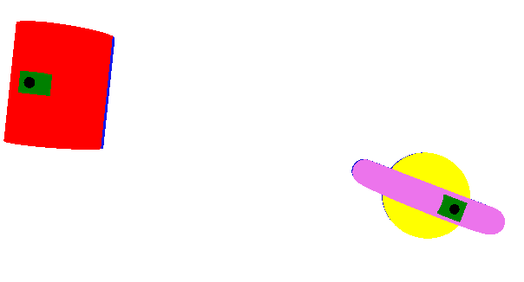
Player 1 & 2 rotating around z axis
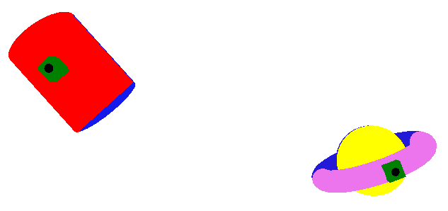

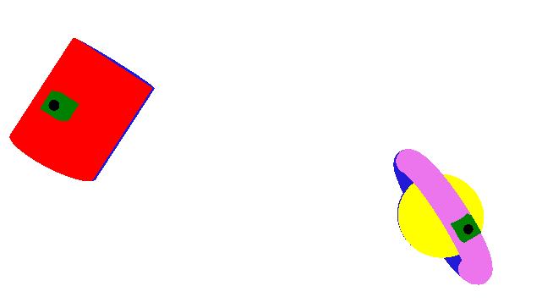

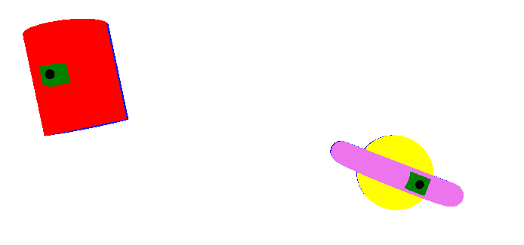
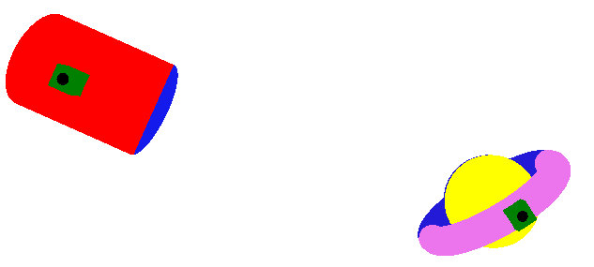
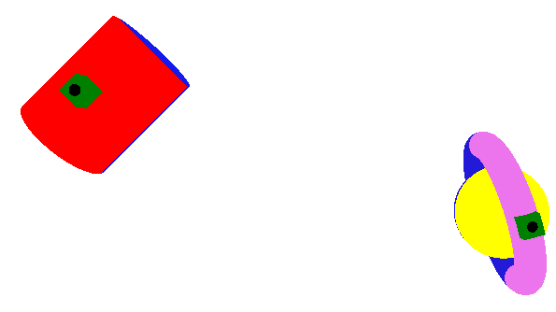
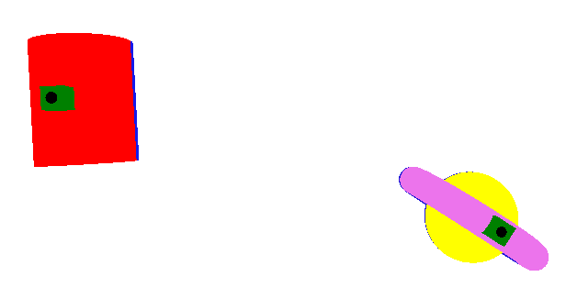

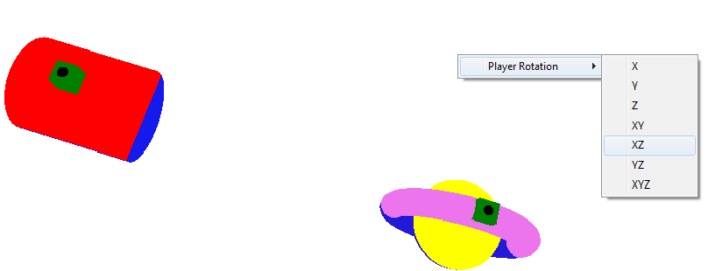
Player rotation mode switched to xz

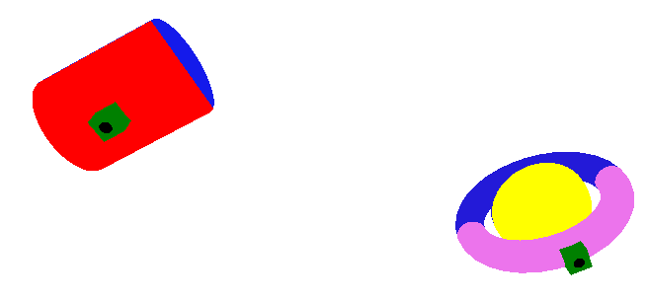
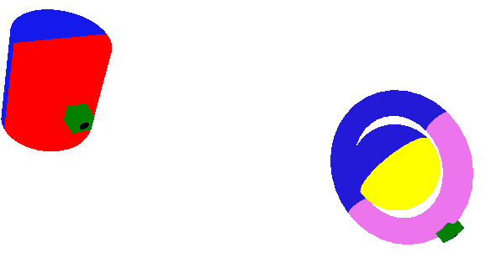
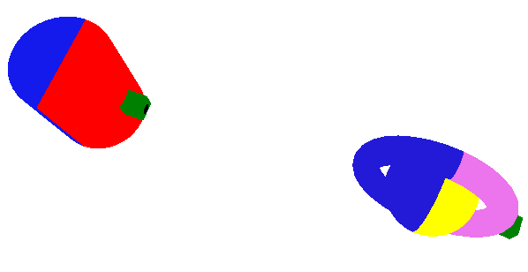

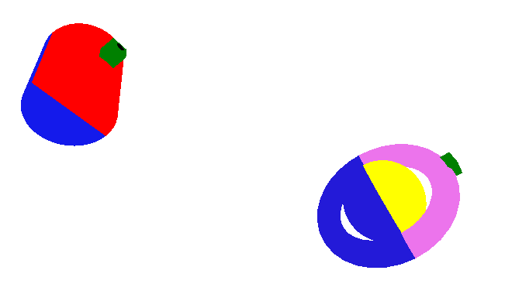
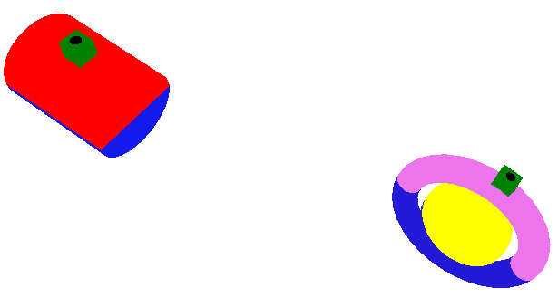
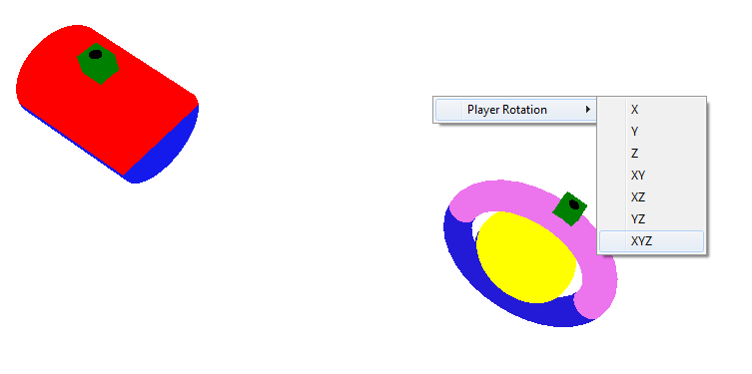
Now rotation mode is switched to xyz
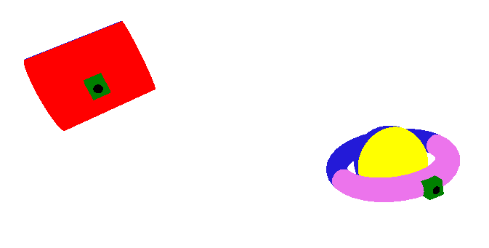
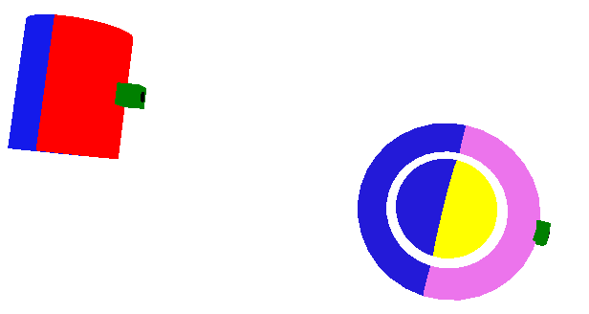
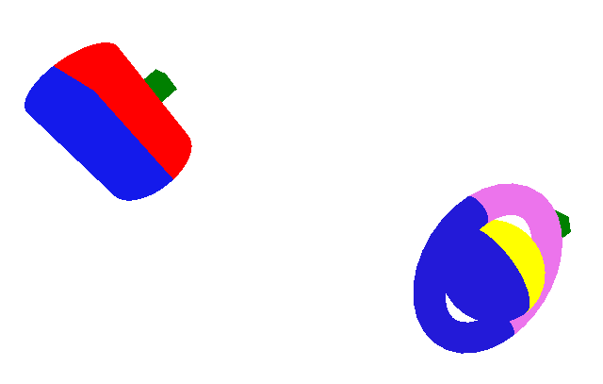
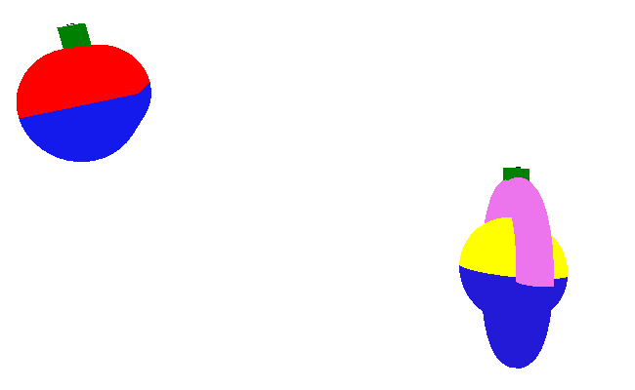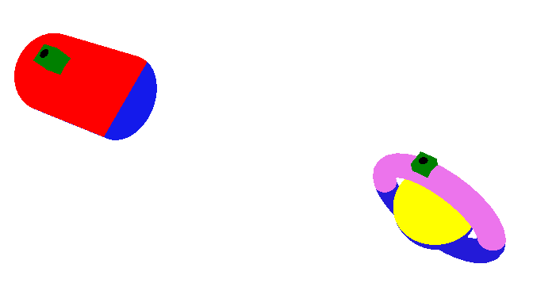
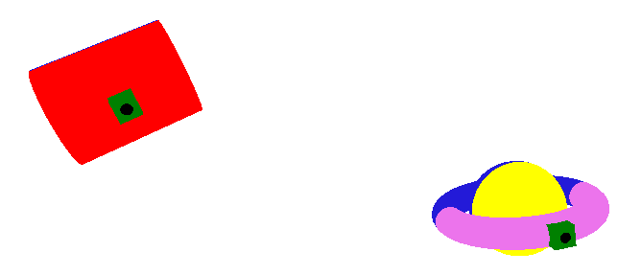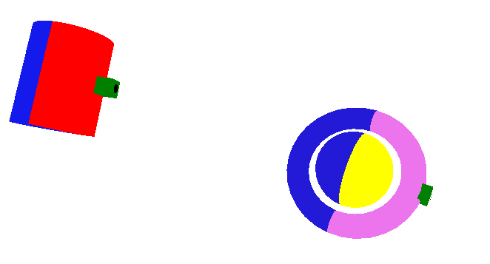

- Collision Detection
When the two players collide, one of them bounces back. The following screenshots illustrate collision detection:
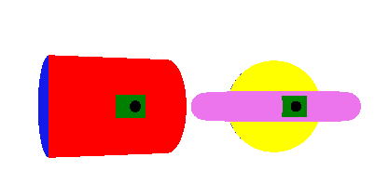
Player 1 & 2 about to collide

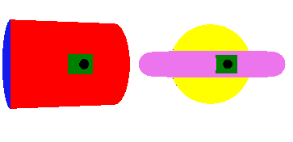
Player 1 bounces back after collision

When one of the players collides with an edge of the window, it simply stops moving and the player is forced to move away from the edge.

- Lighting, and Camera Angle
Lighting parameters can be changed using forms with slider bars. Also material properties for reflecting light changed with a form with slider bars. In this project, two lights can be enabled. When two lights are enabled, some lighting interactions occur.
As for the camera, the camera can be moved, with keyboard keys, in two circular paths around the window. The figure below shows the circular paths.
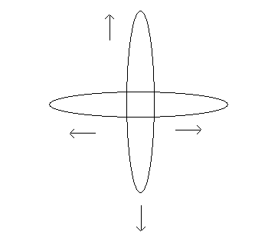
The camera rotates around the screen in a circular motion as keys are pressed.

Here are the keys for moving the camera:
Move Camera Right | Move Camera Left | Move Camera Up | Move Camera Down
4 | 3 | 1 | 2

The following are screenshots demonstrating lighting and camera movement:

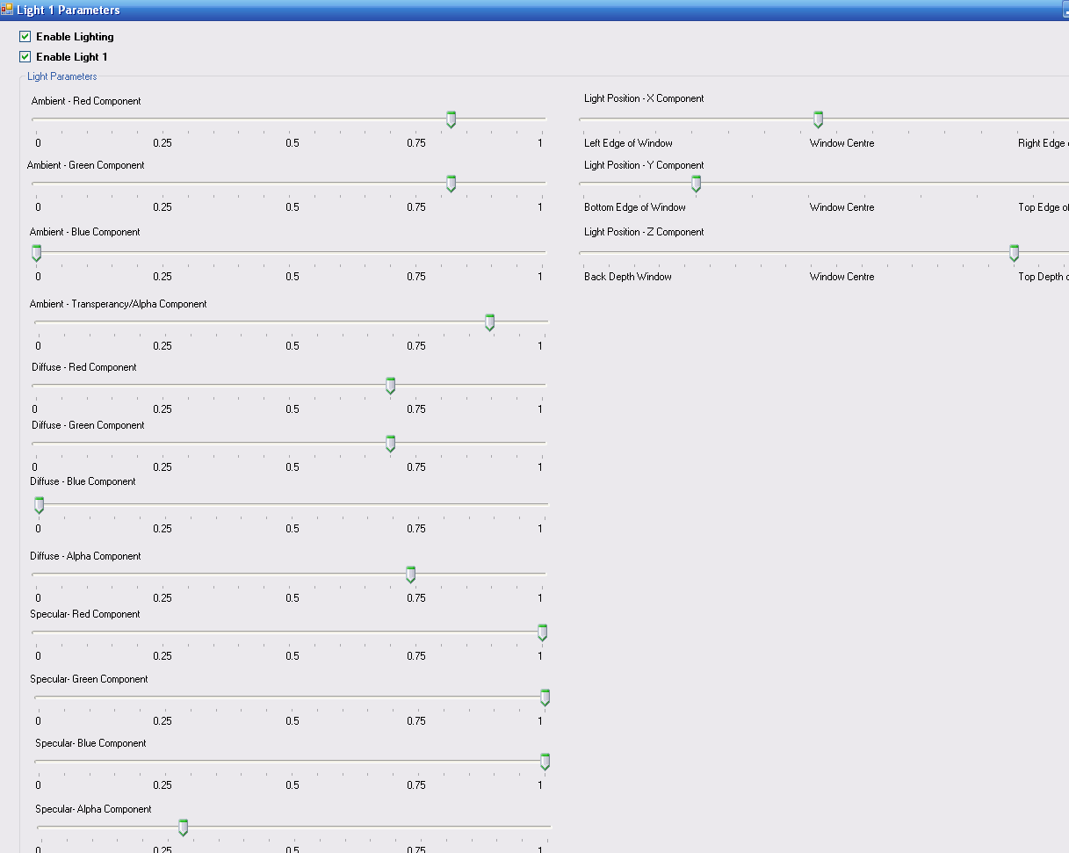
Light 1 Parameters
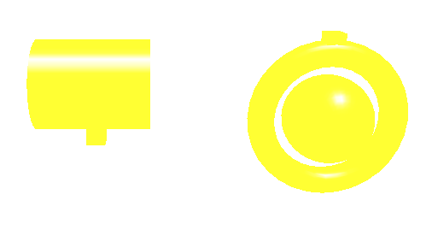
Yellow Light with White Specular Reflection
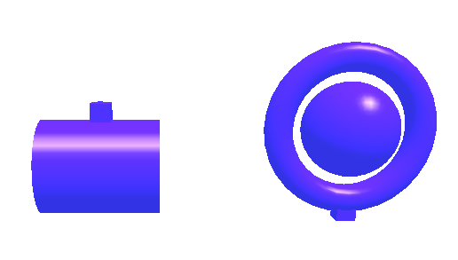
Dark Blue light

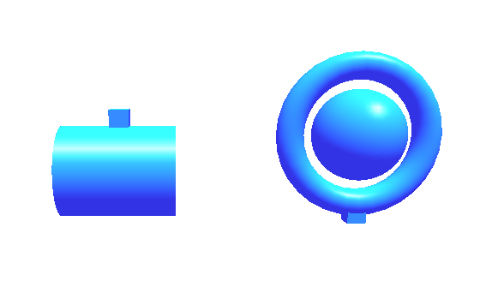
Ambient – Dark Blue
Diffuse – Dark Green
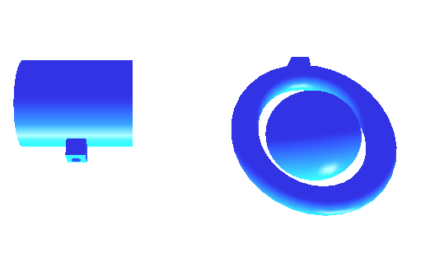

Varying the light position has a clear impact. The light position has three components:
X – Varies from left side of window to right
Y – Varies from bottom of window to top
Z – Varies from near (close to object) to far (far away from object). It also varies from behind and in front of object.
The Z position in the above dark blue ambient and dark green diffuse light screenshots was far behind the players. Now if the Z position is changed to near and in front of the players (holding X & Y constant) the result is the following:
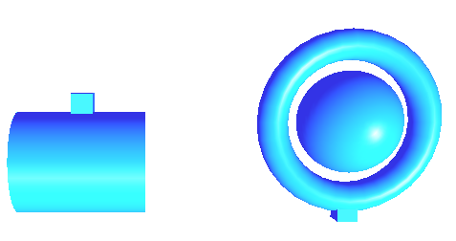


Now if the Z position is moved to far in front of the players the result is the following:
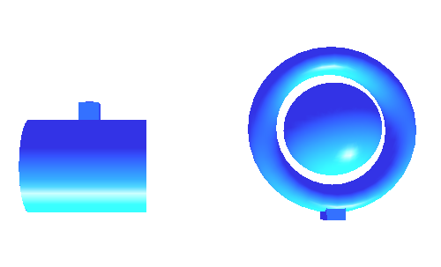
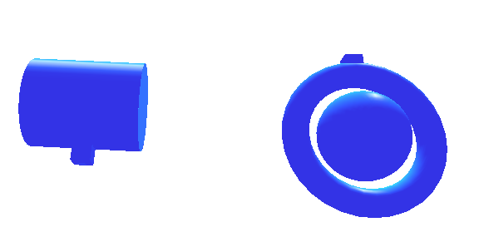

Now the material properties will be changed:
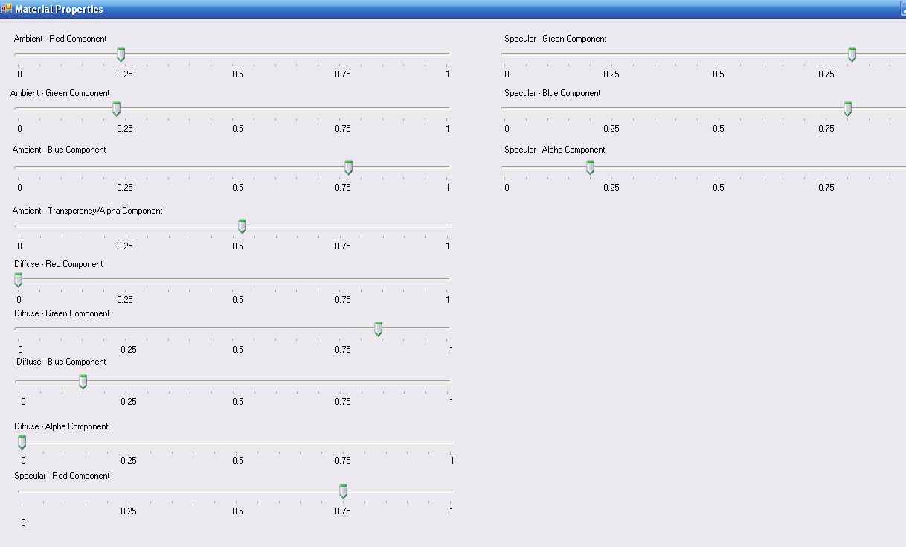
The following is the result:
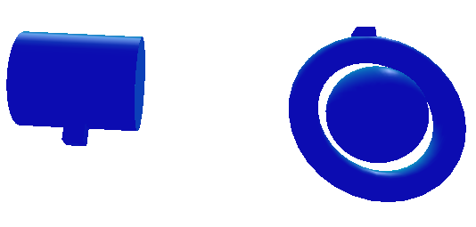

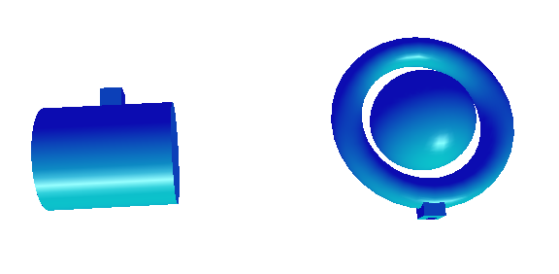
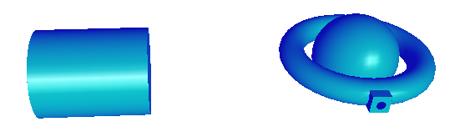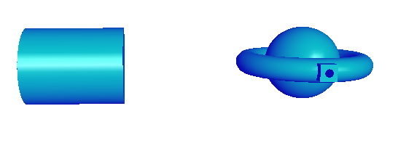
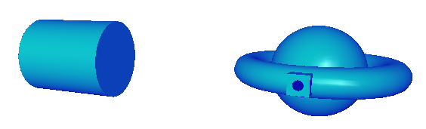
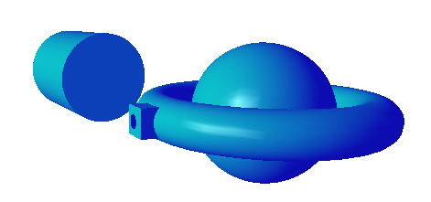
All that remains now is to enable the second light.

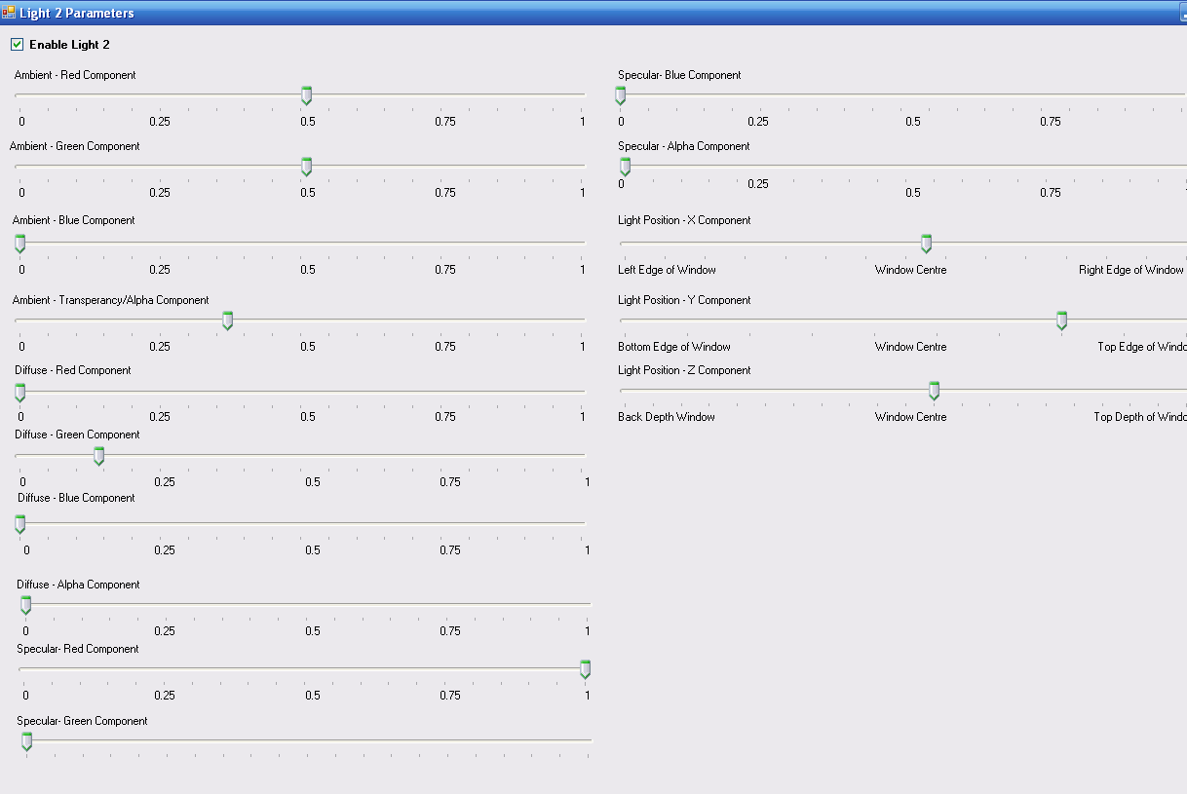
Adding some yellow ambient component, some green diffuse component and red specular component the result is the following:

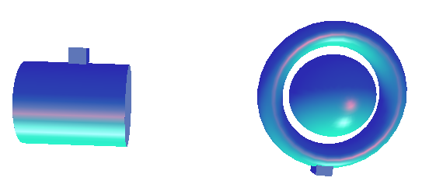
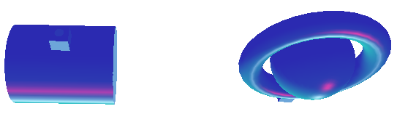
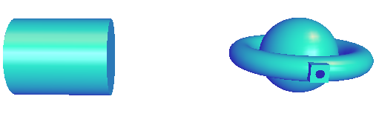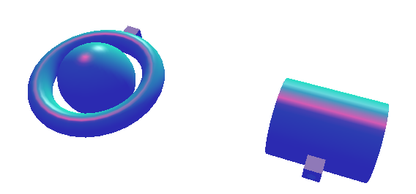
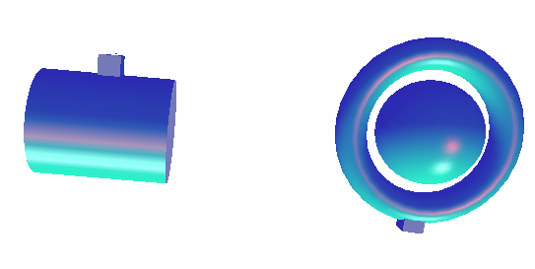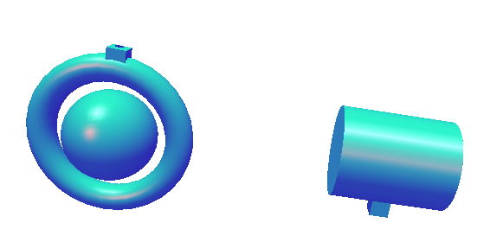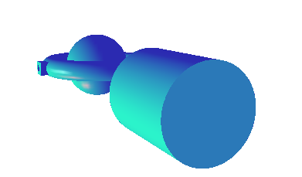

- Shooting
Players can shoot multiple bullets using the shooting keyboard key. The keys for the shooting are:
 | Rotation
Player 2 | Enter
Player 1 | Space

The following screenshots illustrate shooting:
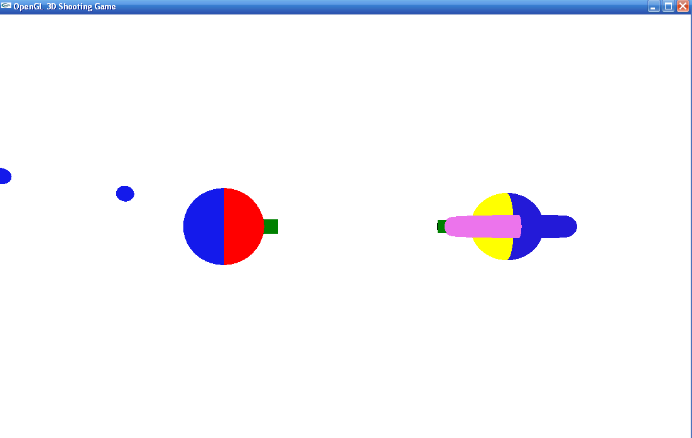
Player 1 shoots
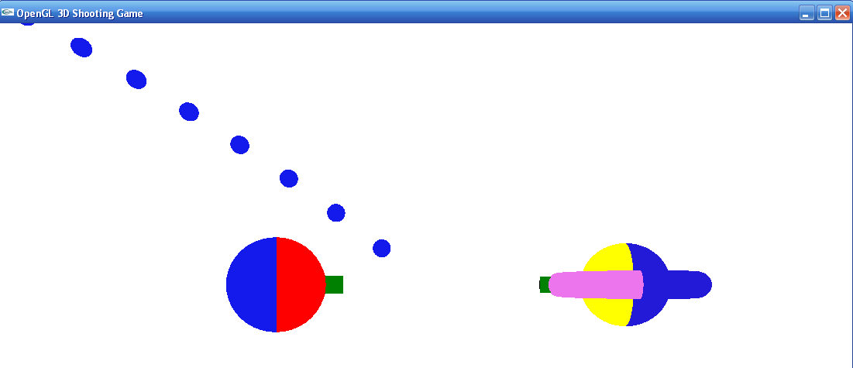

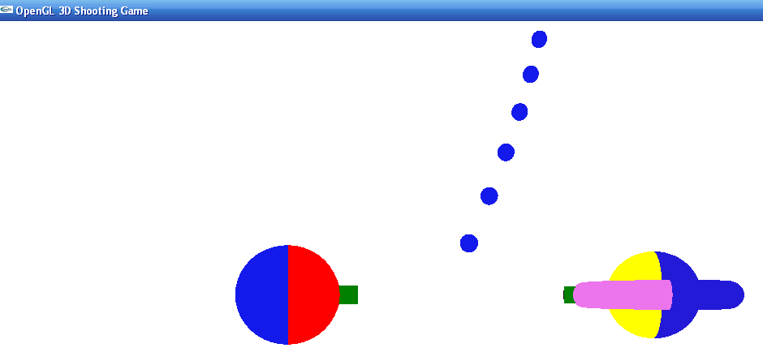
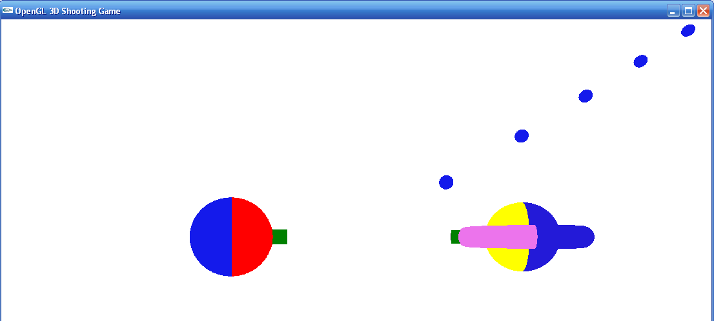
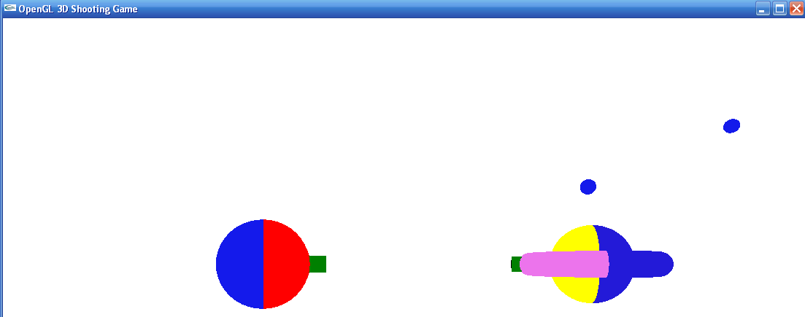

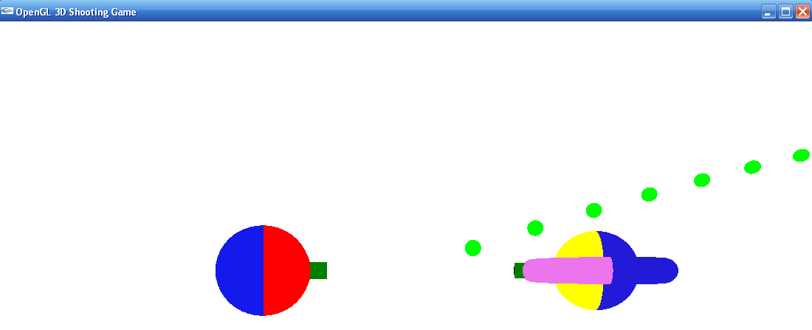
Player 2 shoots
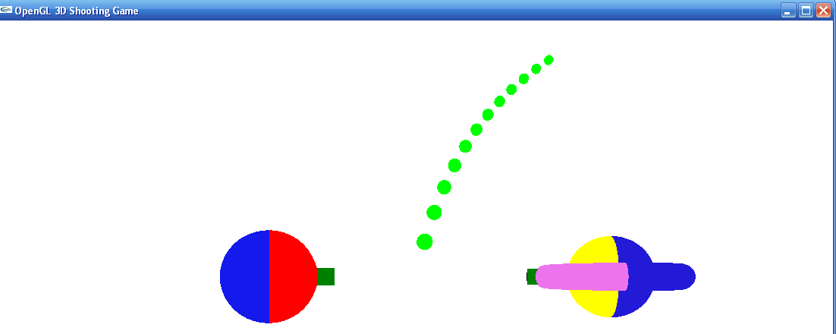
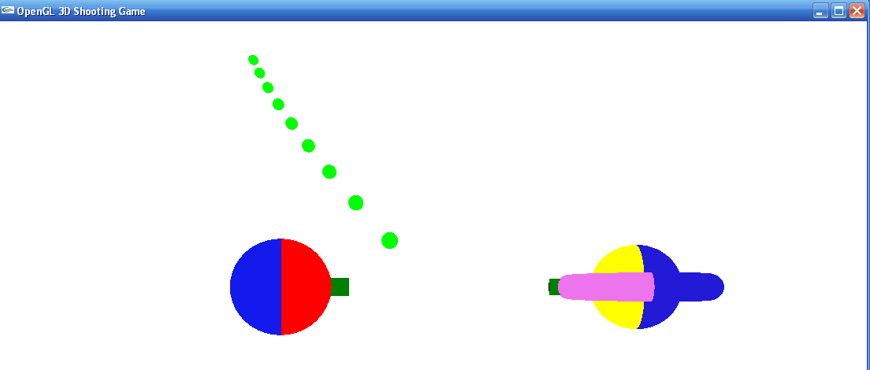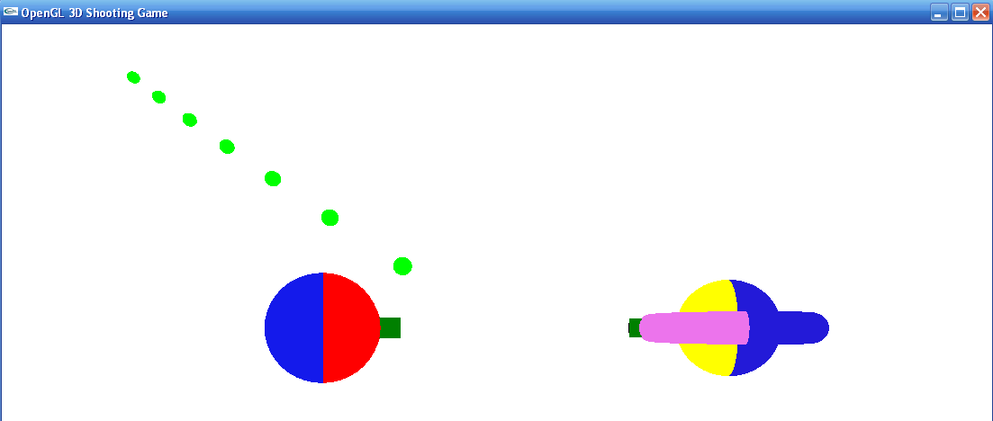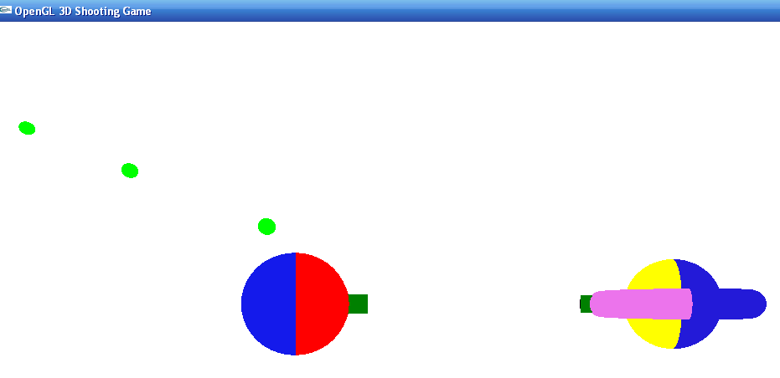
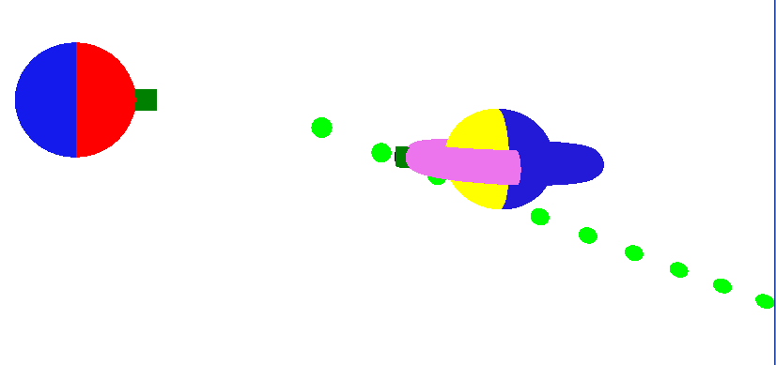
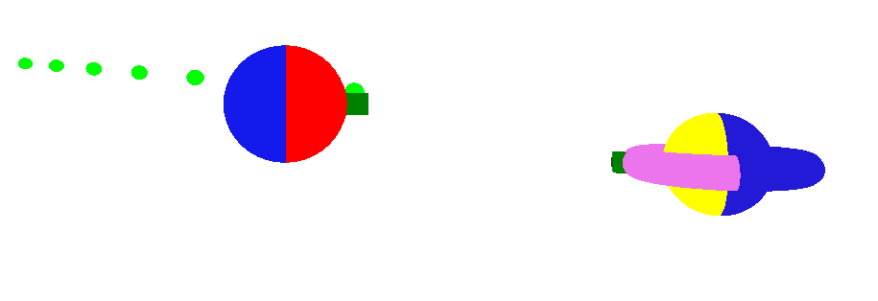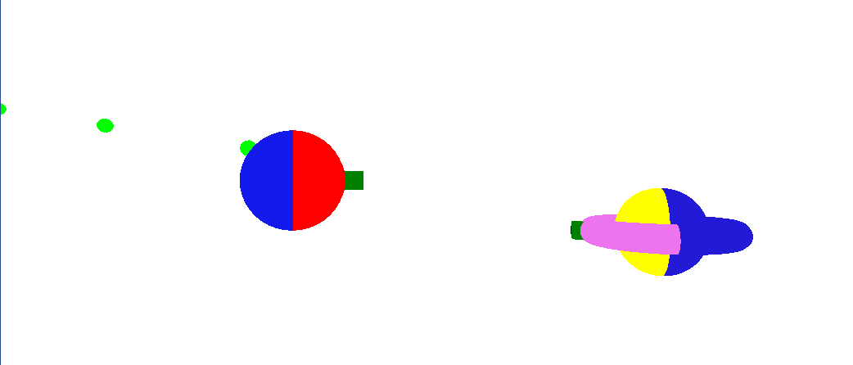
There seems to be an issue with the shooting but it seems minor.
- Appendix: Source Code
Notes:
- Code for Linked List & Lighting Forms not included
- Link List code for the shooting taken from internet – several modifications (ex what variables are part of a list node, return types, etc) to it were needed in order for it to be usable in the program below
- Lighting Forms coded & designed in Visual C# using Visual Studio C# 2008 Express
- Forms Application writes lighting parameters to file, and the program below reads them
- Total lines of code for below program: 968 lines
3DGame.cpp (Source File)
/* Osama Mohammed
CS 5472
3D Game in OpenGL

3DGame.cpp
Lines of Code: 793
*/

#include <stdlib.h>
#include <glut.h>
#include <math.h>
#include <stdio.h>
#include "3DGame.h"
#include "linklist.h"
#include "LinkList.c"

void init()
{

/* attributes */

glClearColor(0.0, 0.0, 0.0, 0.0); /* black background */

qobj = gluNewQuadric();

player1_bullets = CreateList();
player2_bullets = CreateList();

glEnable(GL_NORMALIZE);
glEnable(GL_DEPTH_TEST);

}

void reshape (int w, int h)
{
/* set up viewing */

glViewport (0, 0, (GLsizei) w, (GLsizei) h);
glMatrixMode (GL_PROJECTION);
glLoadIdentity ();
gluPerspective(60.0, (GLfloat) w/(GLfloat) h, 1.0, 20.0);
glMatrixMode(GL_MODELVIEW);
glLoadIdentity();
gluLookAt (0.0, 0.0, 10.0, 0.0, 0.0, 0.0, 0.0, 1.0, 0.0);

float width_resize_ratio = w/(WINDOW_WIDTH + 0.0);
float length_resize_ratio = h/(WINDOW_LENGTH + 0.0);

MIN_X = MIN_X * width_resize_ratio;
MIN_Y = MIN_Y * length_resize_ratio;
edge_collision_factor_player2 = edge_collision_factor_player2 * length_resize_ratio;
edge_collision_factor1_player2 = edge_collision_factor1_player2 * width_resize_ratio;
edge_collision_factor_player1 = edge_collision_factor_player1 * width_resize_ratio;

WINDOW_WIDTH = w;
WINDOW_LENGTH = h;

}

void display() {

glClear (GL_COLOR_BUFFER_BIT | GL_DEPTH_BUFFER_BIT);
glColor3f (0.0, 0.0, 1.0);

keyEventHandler();
arrowKeyEventHandler();

drawPlayer1();
drawPlayer2();

updateBulletPosition(player1_bullets, &player1_bullet_count, 1);
updateBulletPosition(player2_bullets, &player2_bullet_count, 2);

glPushMatrix();
drawBullets(player1_bullets, &player1_bullet_count, 1);
glPopMatrix();

glPushMatrix();
drawBullets(player2_bullets, &player2_bullet_count, 2);
glPopMatrix();

readLight1Parameters();
readLight2Parameters();
readMaterialParameters();

/* enable light 1 */
if (enable_light1)
glEnable(GL_LIGHT1);

/* enable light 2 */
if(enable_light2)
glEnable(GL_LIGHT2);

/* enable lighting */

if(enable_lighting) {

glEnable(GL_LIGHTING);
glShadeModel(GL_SMOOTH);

/* update ambient, diffuse, specular, and position of light 1 parameters */
glLightfv(GL_LIGHT1, GL_AMBIENT, light1_ambient);
glLightfv(GL_LIGHT1, GL_DIFFUSE, light1_diffuse);
glLightfv(GL_LIGHT1, GL_SPECULAR, light1_specular);
glLightfv(GL_LIGHT1, GL_POSITION, light1_position);

/* update ambient, diffuse, specular, and position of light 2 parameters */
glLightfv(GL_LIGHT2, GL_AMBIENT, light2_ambient);
glLightfv(GL_LIGHT2, GL_DIFFUSE, light2_diffuse);
glLightfv(GL_LIGHT2, GL_SPECULAR, light2_specular);
glLightfv(GL_LIGHT2, GL_POSITION, light2_position);

/* update material properties */
glMaterialfv(GL_FRONT, GL_AMBIENT, material_ambient);
glMaterialfv(GL_FRONT, GL_DIFFUSE, material_diffuse);
glMaterialfv(GL_FRONT, GL_SPECULAR, material_specular);
glMaterialf(GL_FRONT, GL_SHININESS, material_shininess);
}

else {
glDisable(GL_LIGHTING);
}

glutSwapBuffers();
}

void drawPlayer1() {

glPushMatrix();

if(enable_light1 == 0 && enable_light2 == 0) {

glScalef(0.45, 0.45, 0.45);
glTranslatef(translate_player1_x, translate_player1_y, translate_player1_z);
glTranslatef(-2.0, 0.0, 0.0);
setPlayerRotation(rotation_mode_player1, rotate_player1);
drawHalfCylinder(RED, player1_cylinder_radius, player1_cylinder_height);
glScalef(0.85, 0.85, 0.85);
glTranslatef(0.0, 0.0, 2.8);
drawCube(1.0, DARK_GREEN);
glTranslatef(0.0, 0.0, 0.57);
drawCircle(0.25, BLACK);
/*setColour(DARK_GREEN);
glTranslatef(-4.5, 0.0, -3.4);
glRotatef(-90, 0.0, 1.0, 0.0);
glutSolidCone(2, 3, 40, 32);
drawCube(3, DARK_GREEN);*/
glPopMatrix();

glPushMatrix();
glScalef(0.45, 0.45, 0.45);
glTranslatef(translate_player1_x, translate_player1_y, translate_player1_z);
glTranslatef(-2.0, 0.0, 0.0);
setPlayerRotation(rotation_mode_player1, rotate_player1);
glRotatef(180, 1.0, 0.0, 0.0);
drawHalfCylinder(LIGHT_BLUE, player1_cylinder_radius, player1_cylinder_height);
}

else {

glScalef(0.45, 0.45, 0.45);
glTranslatef(translate_player1_x, translate_player1_y, translate_player1_z);
setPlayerRotation(rotation_mode_player1, rotate_player1);
glRotatef(-90, 0.0, 1.0, 0.0);
drawCylinder(RED, player1_cylinder_radius, player1_cylinder_height);
drawCircle(player1_cylinder_radius, RED);
glTranslatef(0.0,0.0, 5.0);
drawCircle(player1_cylinder_radius, RED);
glScalef(0.85, 0.85, 0.85);
glTranslatef(-2.7, 0.0, -3.0);
glRotatef(-90, 0.0, 1.0, 0.0);
drawCube(1.0, DARK_GREEN);
glTranslatef(0.0, 0.0, 0.57);
drawCircle(0.25, BLACK);
}

glPopMatrix();

}

void drawPlayer2() {

glPushMatrix();
glScalef(0.90, 0.90, 0.90);
glTranslatef(translate_player2_x, translate_player2_y, translate_player2_z);
glTranslatef(4.0, 0.0, 0.0);
setPlayerRotation(rotation_mode_player2, rotate_player2);
glRotatef(90, 1.0, 0.0, 0.0);
glTranslatef(0.0, -0.8, 0.0);
drawHalfTorus(player2_torus_inner_radius, player2_torus_outer_radius, COLOUR2);
glRotatef(180, 1.0, 0.0, 0.0);
drawHalfTorus(player2_torus_inner_radius, player2_torus_outer_radius, DARK_BLUE);
drawHalfSphere(player2_sphere_radius, DARK_BLUE);
glRotatef(180, 1.0, 0.0, 0.0);
drawHalfSphere(player2_sphere_radius, YELLOW);
glScalef(0.450, 0.450, 0.450);
glTranslatef(0.0, 3.9, 0.0);
drawCube(0.9, DARK_GREEN);
glTranslatef(0.0, 0.5, 0.0);
glRotatef(90, 1.0, 0.0, 0.0);
drawCircle(0.22, BLACK);
glPopMatrix();
}

void drawHalfSphere(float radius, int colour) {

setColour(colour);

double clip_plane1[]={0.0,1.0,0.0,0.0};
glClipPlane(GL_CLIP_PLANE1,clip_plane1);
glEnable(GL_CLIP_PLANE1);
glutSolidSphere(radius, 40, 32);
glDisable(GL_CLIP_PLANE1);
}

void drawSphere(float radius, int colour) {

setColour(colour);
glutSolidSphere(radius, 40, 32);
}

void drawHalfTorus(float innerRadius, float outerRadius, int colour) {

setColour(colour);

double clip_plane1[]={0.0,1.0,0.0,0.0};
glClipPlane(GL_CLIP_PLANE1,clip_plane1);
glEnable(GL_CLIP_PLANE1);
glutSolidTorus(innerRadius, outerRadius, 40, 32);
glDisable(GL_CLIP_PLANE1);
}

void drawCube(float size, int colour) {

setColour(DARK_GREEN);
glutSolidCube(size);
}

void setPlayerRotation(int rotation_mode, float rotation_angle) {

switch(rotation_mode) {

case Y_ROTATION:
glRotatef(rotation_angle, 0.0, 1.0, 0.0);
break;

case X_ROTATION:
glRotatef(rotation_angle, 1.0, 0.0, 0.0);
break;

case Z_ROTATION:
glRotatef(rotation_angle, 0.0, 0.0, 1.0);
break;

case XY_ROTATION:
glRotatef(rotation_angle, 1.0, 1.0, 0.0);
break;

case XYZ_ROTATION:
glRotatef(rotation_angle, 1.0, 1.0, 1.0);
break;

case YZ_ROTATION:
glRotatef(rotation_angle, 0.0, 1.0, 1.0);
break;

case XZ_ROTATION:
glRotatef(rotation_angle, 1.0, 0.0, 1.0);
break;

}
}

void drawHalfCylinder(int colour, float radius, float height) {

int STEPS = 20;
float DELTA = PI/STEPS;
float angle = 0;

setColour(colour);

glBegin(GL_POLYGON);

for(int step=0; step<=STEPS; ++step) {
angle = step*DELTA;
glVertex3f(height/2.0,radius*cos(angle),radius*sin(angle));
}

glEnd();

glBegin(GL_POLYGON);

for(int step=0; step<=STEPS; ++step) {
angle = step*DELTA;
glVertex3f(-height/2.0,radius*cos(angle),radius*sin(angle));
}

glEnd();

glBegin(GL_QUADS);

for(int step=0; step<STEPS; ++step) {

float angle1 = step*DELTA; // at this angle the quad starts
float angle2 = (step+1)*DELTA; // look ahead of next angle: at this angle the quad ends
float rsine1 = radius*sin(angle1);
float rcosine1 = radius*cos(angle1);
float rsine2 = radius*sin(angle2);
float rcosine2 = radius*cos(angle2);
glVertex3f(height/2,rcosine1,rsine1);
glVertex3f(height/2,rcosine2,rsine2);
glVertex3f(-height/2,rcosine2,rsine2);
glVertex3f(-height/2,rcosine1,rsine1);
}

glEnd();

}

void drawCylinder(int colour, float radius, float height) {

setColour(colour);

gluCylinder(qobj, radius, radius, height, 40, 32);
}

void drawCircle(float radius, int colour) {

setColour(colour);

glBegin(GL_POLYGON);

for(int angle = 0; angle <=360; angle = angle + 5) {

glVertex3f(radius*cos(angle * PI/180), radius * sin(angle * PI/180), 0);
}

glEnd();
}

void moveCamera() {

glMatrixMode(GL_MODELVIEW);
glLoadIdentity();
gluLookAt (0.0, 0.0, 10.0, 0.0, 0.0, 0.0, 0.0, 1.0, 0.0);
glRotatef(eye_x, 1.0, 0.0, 0.0);
glRotatef(eye_y, 0.0, 1.0, 0.0);
}

int detectPlayerCollision() {

if(player1_x_initial_position + translate_player1_x >= player2_x_initial_position + translate_player2_x - player2_scale_radius &&
player1_x_initial_position + translate_player1_x <= player2_x_initial_position + translate_player2_x + player2_scale_radius &&
player1_y_initial_position + translate_player1_y >= player2_y_initial_position + translate_player2_y - player2_scale_radius &&
player1_y_initial_position + translate_player1_y <= player2_y_initial_position + translate_player2_y + player2_scale_radius &&
translate_player1_z == translate_player2_z) {
return 1;
}

return 0;
}

void seperatePlayers() {

translate_player1_x = translate_player1_x - 0.7;
}

void arrowKeyEventHandler() {

if(specialKeys[GLUT_KEY_UP]) {

if(translate_player2_y + edge_collision_factor_player2 <= -MIN_Y) {
translate_player2_y = translate_player2_y + player2_displacement;
}
}

if (specialKeys[GLUT_KEY_DOWN]) {

if(translate_player2_y - edge_collision_factor_player2 >= MIN_Y) {
translate_player2_y = translate_player2_y - player2_displacement;
}
}

if(specialKeys[GLUT_KEY_LEFT]) {

if (translate_player2_x >= MIN_X) {
translate_player2_x = translate_player2_x - player2_displacement;
}
}

if(specialKeys[GLUT_KEY_RIGHT]) {

if (translate_player2_x + edge_collision_factor1_player2 <= -MIN_X) {
translate_player2_x = translate_player2_x + player2_displacement;
}
}

if(detectPlayerCollision())
seperatePlayers();

}

void keyEventHandler() {

if(keys[KEY_CODE_X] || keys[KEY_CODE_x]) {

rotate_player1 = rotate_player1 + 3;

if(rotate_player1 >= 180)
rotate_player1 = -180;
}

if(keys[KEY_CODE_P] || keys[KEY_CODE_p]) {

rotate_player2 = rotate_player2 + 3;

if(rotate_player2 >= 180)
rotate_player2 = -180;
}

if(keys[KEY_CODE_A] || keys[KEY_CODE_a]) {

if (translate_player1_x >= MIN_X) {
translate_player1_x = translate_player1_x - player1_displacement;
}
}

if(keys[KEY_CODE_S] || keys[KEY_CODE_s]) {

if(translate_player1_y >= MIN_Y) {
translate_player1_y = translate_player1_y - player1_displacement;
}
}

if(keys[KEY_CODE_W] || keys[KEY_CODE_w]) {

if(translate_player1_y <= -MIN_Y) {
translate_player1_y = translate_player1_y + player1_displacement;
}
}

if(keys[KEY_CODE_D] || keys[KEY_CODE_d]) {

if (translate_player1_x - edge_collision_factor_player1 <= -MIN_X) {
translate_player1_x = translate_player1_x + player1_displacement;
}
}

if(keys[KEY_CODE_R] || keys[KEY_CODE_r]) {

}

if(keys[KEY_CODE_I] || keys[KEY_CODE_i]) {

translate_player2_z = translate_player2_z + player2_displacement;
}

if(keys[KEY_CODE_O] || keys[KEY_CODE_o]) {

translate_player2_z = translate_player2_z - player2_displacement;
}

if(keys[KEY_CODE_C] || keys[KEY_CODE_c]) {

translate_player1_z = translate_player1_z + player1_displacement;
}

if(keys[KEY_CODE_F] || keys[KEY_CODE_f]) {

translate_player1_z = translate_player1_z - player1_displacement;
}

if(keys[KEY_CODE_SPACE]) {

addBullet(player1_bullets, &player1_bullet_count, player1_x_initial_position + translate_player1_x,
player1_y_initial_position + translate_player1_y, player1_z_initial_position + translate_player1_z, rotate_player1);
}

if(keys[KEY_CODE_ENTER]) {

addBullet(player2_bullets, &player2_bullet_count, player2_x_initial_position + translate_player2_x,
player2_y_initial_position + translate_player2_y, player2_z_initial_position + translate_player2_z, rotate_player2);
}

if(keys[KEY_CODE_1]) {

eye_x = eye_x + camera_increment;
moveCamera();
}

if(keys[KEY_CODE_2]) {

eye_x = eye_x - camera_increment;
moveCamera();
}

if(keys[KEY_CODE_3]) {

eye_y = eye_y + camera_increment;
moveCamera();
}

if(keys[KEY_CODE_4]) {

eye_y = eye_y - camera_increment;
moveCamera();
}

if(keys[KEY_CODE_5]) {

eye_x = 0;
eye_y = 0;
reshape(WINDOW_WIDTH, WINDOW_LENGTH);
}
}

void keyPressDown(unsigned char key, int x, int y) {

keys[key]=1;
glutPostRedisplay();
}

void keyPressUp(unsigned char key, int x, int y) {

keys[key]=0;
glutPostRedisplay();
}

void arrowKeyDown(int key, int x, int y) {

specialKeys[key] = 1;
glutPostRedisplay();
}

void arrowKeyUp(int key, int x, int y) {

specialKeys[key] = 0;
glutPostRedisplay();
}

void readLight1Parameters() {

FILE *pFile;

pFile = fopen("c://lightParameters.txt", "r");

if (pFile != NULL) {

fscanf(pFile, "%d", &enable_lighting);
fscanf(pFile, "%d", &enable_light1);
fscanf(pFile, "%f", &light1_ambient[0]);
fscanf(pFile, "%f", &light1_ambient[1]);
fscanf(pFile, "%f", &light1_ambient[2]);
fscanf(pFile, "%f", &light1_ambient[3]);
fscanf(pFile, "%f", &light1_diffuse[0]);
fscanf(pFile, "%f", &light1_diffuse[1]);
fscanf(pFile, "%f", &light1_diffuse[2]);
fscanf(pFile, "%f", &light1_diffuse[3]);
fscanf(pFile, "%f", &light1_specular[0]);
fscanf(pFile, "%f", &light1_specular[1]);
fscanf(pFile, "%f", &light1_specular[2]);
fscanf(pFile, "%f", &light1_specular[3]);
fscanf(pFile, "%f", &light1_position[0]);
fscanf(pFile, "%f", &light1_position[1]);
fscanf(pFile, "%f", &light1_position[2]);
fclose(pFile);
}

}

void readLight2Parameters() {

FILE *pFile;

pFile = fopen("c://light2Parameters.txt", "r");

if (pFile != NULL) {

fscanf(pFile, "%d", &enable_light2);
fscanf(pFile, "%f", &light2_ambient[0]);
fscanf(pFile, "%f", &light2_ambient[1]);
fscanf(pFile, "%f", &light2_ambient[2]);
fscanf(pFile, "%f", &light2_ambient[3]);
fscanf(pFile, "%f", &light2_diffuse[0]);
fscanf(pFile, "%f", &light2_diffuse[1]);
fscanf(pFile, "%f", &light2_diffuse[2]);
fscanf(pFile, "%f", &light2_diffuse[3]);
fscanf(pFile, "%f", &light2_specular[0]);
fscanf(pFile, "%f", &light2_specular[1]);
fscanf(pFile, "%f", &light2_specular[2]);
fscanf(pFile, "%f", &light2_specular[3]);
fscanf(pFile, "%f", &light2_position[0]);
fscanf(pFile, "%f", &light2_position[1]);
fscanf(pFile, "%f", &light2_position[2]);
fclose(pFile);
}

}

void readMaterialParameters() {

FILE *pFile;

pFile = fopen("c://materialParameters.txt", "r");

if (pFile != NULL) {

fscanf(pFile, "%f", &material_ambient[0]);
fscanf(pFile, "%f", &material_ambient[1]);
fscanf(pFile, "%f", &material_ambient[2]);
fscanf(pFile, "%f", &material_ambient[3]);
fscanf(pFile, "%f", &material_diffuse[0]);
fscanf(pFile, "%f", &material_diffuse[1]);
fscanf(pFile, "%f", &material_diffuse[2]);
fscanf(pFile, "%f", &material_diffuse[3]);
fscanf(pFile, "%f", &material_specular[0]);
fscanf(pFile, "%f", &material_specular[1]);
fscanf(pFile, "%f", &material_specular[2]);
fscanf(pFile, "%f", &material_specular[3]);
fclose(pFile);
}
}

void addBullet(List bullets, int *player_bullet_count, float ibx, float iby, float ibz, float angle) {

*player_bullet_count = *player_bullet_count + 1;

int result = InsertInList(*player_bullet_count, ibx, iby, ibz, 0, 0, 0, angle - 90, angle - 90, angle, bullets);

}

void removeBullet(List bullets, int index, int *player_bullet_count) {

DeleteInList(index, bullets);

*player_bullet_count = *player_bullet_count - 1;
}

void updateBulletPosition(List bullets, int *player_bullet_count, int player) {

for(int i = 1; i <= *player_bullet_count; i++) {

Node bullet = SelectInList(i, bullets);

if(bullet->initial_bullet_x + bullet->translate_bullet_x >= MIN_X && bullet->initial_bullet_x + bullet->translate_bullet_x <= -MIN_X &&
bullet->initial_bullet_y + bullet->translate_bullet_y >= MIN_Y && bullet->initial_bullet_y + bullet->translate_bullet_y <= -MIN_Y) {

if((player == 1 && bullet->initial_bullet_x + bullet->translate_bullet_x >= player2_x_initial_position + translate_player2_x - player2_scale_radius
&& bullet->initial_bullet_x + bullet->translate_bullet_x <= player2_x_initial_position + translate_player2_x + player2_scale_radius
&& bullet->initial_bullet_y + bullet->translate_bullet_y <= player2_y_initial_position + translate_player2_y - player2_scale_radius
&& bullet->initial_bullet_y + bullet->translate_bullet_y >= player2_y_initial_position + translate_player2_y + player2_scale_radius) ||
(player == 2 && bullet->initial_bullet_x + bullet->translate_bullet_x >= player1_x_initial_position + translate_player1_x - player1_cylinder_scale_radius
&& bullet->initial_bullet_x + bullet->translate_bullet_x <= player1_x_initial_position + translate_player1_x + player1_cylinder_scale_radius
&& bullet->initial_bullet_y + bullet->translate_bullet_y <= player1_y_initial_position + translate_player1_y - player1_cylinder_scale_radius
&& bullet->initial_bullet_y + bullet->translate_bullet_y >= player1_y_initial_position + translate_player1_y + player1_cylinder_scale_radius))
{

removeBullet(bullets, i, player_bullet_count);
}

else {

bullet->translate_bullet_x += cos(bullet->bullet_angle_x * PI/180) * player_bullet_pixel_speed;
bullet->translate_bullet_y += sin(bullet->bullet_angle_y * PI/180) * player_bullet_pixel_speed;
bullet->translate_bullet_z += cos(bullet->bullet_angle_z * PI/180) * player_bullet_pixel_speed;

}
}

else {

removeBullet(bullets, i, player_bullet_count);
}
}

}

void drawBullets(List bullets, int *player_bullet_count, int player) {

for(int i = 1; i <= *player_bullet_count; i++) {

Node bullet = SelectInList(i, bullets);

glTranslatef(bullet->initial_bullet_x + bullet->translate_bullet_x, 0.0, 0.0);
glTranslatef(0.0, bullet->initial_bullet_y + bullet->translate_bullet_y, 0.0);
glTranslatef(0.0, 0.0, bullet->initial_bullet_z + bullet->translate_bullet_z);

if(player == 1)
drawSphere(0.2, LIGHT_BLUE);
else if(player == 2)
drawSphere(0.2, GREEN);

glutPostRedisplay();
/*glPointSize(3.0);
glBegin(GL_POINTS);
glVertex3f(0,0,0);
glVertex3f(bullet->initial_bullet_x + bullet->translate_bullet_x,
bullet->initial_bullet_y + bullet->translate_bullet_y,
bullet->initial_bullet_z + bullet->translate_bullet_z);
glEnd();*/
}

}

void setColour(int colour) {

switch(colour) {

case RED:
glColor3f(1.0, 0.0, 0.0);
break;

case GREEN:
glColor3f(0.0, 1.0, 0.0);
break;

case LIGHT_BLUE:
glColor3f(0.078, 0.102, 0.922);
break;

case YELLOW:
glColor3f(1.0, 1.0, 0.0);
break;

case BLACK:
glColor3f(0.0, 0.0, 0.0);
break;

case DARK_GREEN:
glColor3f(0.0, 0.5, 0.0);
break;

case COLOUR1:
glColor3f(0.465, 0.641, 0.781);
break;

case DARK_BLUE:
glColor3f(0.137, 0.102, 0.848);
break;

case COLOUR2:
glColor3f(0.926, 0.453, 0.926);
break;
}
}

void processMenuEvents(int mode) {

rotation_mode_player1 = mode;
rotation_mode_player2 = mode;
}

void createRotationModeMenu() {

int menu,submenu;

submenu = glutCreateMenu(processMenuEvents);
glutAddMenuEntry("X", X_ROTATION);
glutAddMenuEntry("Y", Y_ROTATION);
glutAddMenuEntry("Z", Z_ROTATION);
glutAddMenuEntry("XY", XY_ROTATION);
glutAddMenuEntry("XZ", XZ_ROTATION);
glutAddMenuEntry("YZ", YZ_ROTATION);
glutAddMenuEntry("XYZ", XYZ_ROTATION);

menu = glutCreateMenu(processMenuEvents);
glutAddSubMenu("Player Rotation",submenu);
glutAttachMenu(GLUT_RIGHT_BUTTON);

}

int main(int argc, char** argv)
{
glutInit(&argc, argv);
glutInitDisplayMode (GLUT_DOUBLE | GLUT_RGB | GLUT_DEPTH);
glutInitWindowSize (WINDOW_WIDTH, WINDOW_LENGTH);
glutInitWindowPosition (0, 0);
glutCreateWindow ("OpenGL 3D Shooting Game");
init();
glutDisplayFunc(display);
glutReshapeFunc(reshape);
glutSpecialFunc(arrowKeyDown);
glutSpecialUpFunc(arrowKeyUp);
glutKeyboardFunc(keyPressDown);
glutKeyboardUpFunc(keyPressUp);
createRotationModeMenu();
glutMainLoop();

return 0;
}

3DGame.h (Header File)
/* Osama Mohammed
CS 5472
3D Game in OpenGL

3DGame.h
Lines of Code: 175
*/

#include "LinkList.h"

#define RED 1
#define GREEN 2
#define YELLOW 3
#define LIGHT_BLUE 4
#define BLACK 5
#define DARK_GREEN 6
#define COLOUR1 7
#define DARK_BLUE 8
#define COLOUR2 9
#define PI 3.14159265
#define X_ROTATION 0
#define Y_ROTATION 1
#define XY_ROTATION 2
#define XYZ_ROTATION 3
#define YZ_ROTATION 4
#define XZ_ROTATION 5
#define Z_ROTATION 6
#define KEY_CODE_a 97
#define KEY_CODE_A 65
#define KEY_CODE_s 115
#define KEY_CODE_S 83
#define KEY_CODE_w 119
#define KEY_CODE_W 87
#define KEY_CODE_D 68
#define KEY_CODE_d 100
#define KEY_CODE_R 82
#define KEY_CODE_r 114
#define KEY_CODE_SPACE 32
#define KEY_CODE_ENTER 13
#define KEY_CODE_P 80
#define KEY_CODE_p 112
#define KEY_CODE_X 88
#define KEY_CODE_x 120
#define KEY_CODE_I 73
#define KEY_CODE_i 105
#define KEY_CODE_o 111
#define KEY_CODE_O 79
#define KEY_CODE_C 67
#define KEY_CODE_c 99
#define KEY_CODE_F 70
#define KEY_CODE_f 102
#define KEY_CODE_1 49
#define KEY_CODE_2 50
#define KEY_CODE_3 51
#define KEY_CODE_4 52
#define KEY_CODE_5 53

int WINDOW_WIDTH = 1100;
int WINDOW_LENGTH = 675;
float MIN_X = -14.00;
float MIN_Y = -9.72;
int rotation_mode_player1 = 1;
int rotation_mode_player2 = 1;
int keys[256];
int specialKeys[256];

float player1_displacement = 0.12;
float player2_displacement = 0.065;
float player1_cylinder_radius = 2.0;
float player1_cylinder_scale_radius = 0.45 * player1_cylinder_radius;
float player1_cylinder_height = 5.0;
float player1_scale_cylinder_height = 0.45 * player1_cylinder_height;
float player2_torus_inner_radius = 0.3;
float player2_torus_outer_radius = 1.5;
float player2_sphere_radius = 1.0;
float player2_total_radius = player2_torus_inner_radius + player2_torus_outer_radius + player2_sphere_radius;
float player2_scale_radius = 0.90 * player2_total_radius;
float rotate_player1 = 0;
float rotate_player2 = 0;
float player1_x_initial_position = 0.0;
float player1_y_initial_position = 0.0;
float player1_z_initial_position = 0.0;
float player2_x_initial_position = 4.23;
float player2_y_initial_position = 0.0;
float player2_z_initial_position = 0.0;
float translate_player1_x = 0;
float translate_player1_y = 0;
float translate_player1_z = 0;
float translate_player2_x = 0;
float translate_player2_y = 0;
float translate_player2_z = 0;
float edge_collision_factor_player2 = 4.5;
float edge_collision_factor1_player2 = 9.0;
float edge_collision_factor_player1 = 5.0;

float eye_x = 0.0;
float eye_y = 0.0;
float eye_z = 0.0;
float camera_increment = 1.0;

GLUquadricObj *qobj;

/* Lighting parameters */

/* ambient, diffuse, and specular */

GLfloat light1_ambient[4] = {1.0, 0.0, 0.0, 1.0};
GLfloat light1_diffuse[4] = {1.0, 1.0, 1.0, 1.0};
GLfloat light1_specular[4] = {1.0, 0.0, 1.0, 1.0};

GLfloat light2_ambient[4] = {1.0, 0.0, 0.0, 1.0};
GLfloat light2_diffuse[4] = {1.0, 1.0, 1.0, 1.0};
GLfloat light2_specular[4] = {1.0, 0.0, 1.0, 1.0};

/* Light position */
GLfloat light1_position[4] = {-1.0, 0.0, 1.0, 0.0};
GLfloat light2_position[4] = {1.0, 0.0, 1.0, 0.0};

/* Material Parameters */

GLfloat material_ambient[4] = {1.0, 1.0, 1.0, 1.0};
GLfloat material_diffuse[4] = {1.0, 1.0, 1.0, 1.0};
GLfloat material_specular[4] = {1.0, 1.0, 1.0, 1.0};
GLfloat material_shininess = 100.0;

int enable_lighting = 0;
int enable_light1 = 0;
int enable_light2 = 0;

List player1_bullets;
List player2_bullets;

int player1_bullet_count = 0;
int player2_bullet_count = 0;
float player_bullet_pixel_speed = 0.05;

void display();
void init();
void reshape (int w, int h);
void moveCamera();
void drawPlayer1();
void drawPlayer2();
void drawCube(float size, int colour);
void drawSphere(float radius, int colour);
void drawHalfCylinder(int colour, float radius, float height);
void drawHalfSphere(float radius, int colour);
void drawHalfTorus(float innerRadius, float outerRadius, int colour);
void drawCylinder(int colour, float radius, float height);
void drawCircle(float radius, int colour);
void setPlayerRotation(int rotation_mode, float rotation_angle);
int detectPlayerCollision();
void seperatePlayers();
void updatePlayer1Position();
void updatePlayer2Position();

void setColour(int colour);
void keyEventHandler();
void arrowKeyEventHandler();
void keyPressDown(unsigned char key, int x, int y);
void keyPressUp(unsigned char key, int x, int y);
void arrowKeyDown(int key, int x, int y);
void arrowKeyUp(int key, int x, int y);

void readLight1Parameters();
void readLight2Parameters();
void readMaterialParameters();

void addBullet(List bullets, int *player_bullet_count, float ibx, float iby, float ibz, float angle);
void removeBullet(List bullets, int index, int *player_bullet_count);
void updateBulletPosition(List bullets, int *player_bullet_count, int player);
void drawBullets(List bullets, int *player_bullet_count, int player);

void createRotationModeMenu();
void processMenuEvents(int mode);

